**Lab 9**

**String Instruction**

**Program 1 : Compare two strings and display message accordingly in Assembly Language.**

.model small

.stack 100h

.data

msg1 db "This is 1st string$"

msg2 db "This is 2nd string$"

cmp1 db 'Both the strings are equal$'

cmp2 db 'both the strings are not equal$'

.code

start:

Mov ax,@data

Mov ds, ax

mov ah,09

lea dx,msg1

int 21h

mov dl,10

mov ah,02

int 21h

mov ah,09

lea dx ,msg2

int 21h

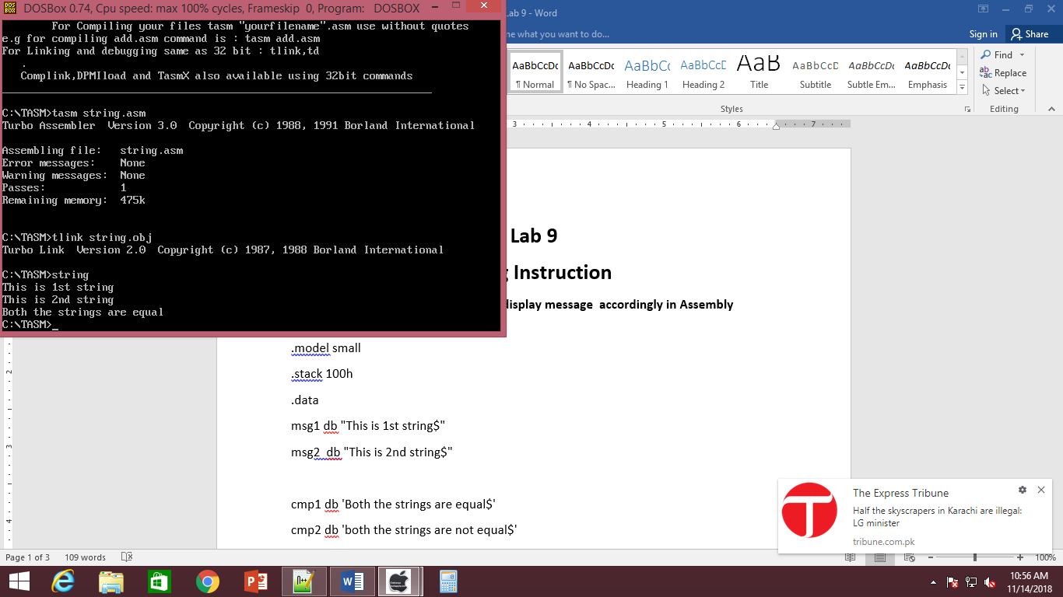

mov dl,10

mov ah,02

int 21h

mov al, msg1

mov bl,msg2

cmp al,bl

je equal

cmp al,bl

jne not_equal

not_equal:

mov ah,09

lea dx,cmp2

int 21h

equal:

mov ah,09

lea dx,cmp1

int 21h

mov ah,4ch

int 21h

end start

**Program 2:Take input a string and print it on screen.**

.model small

.stack 100h

.data

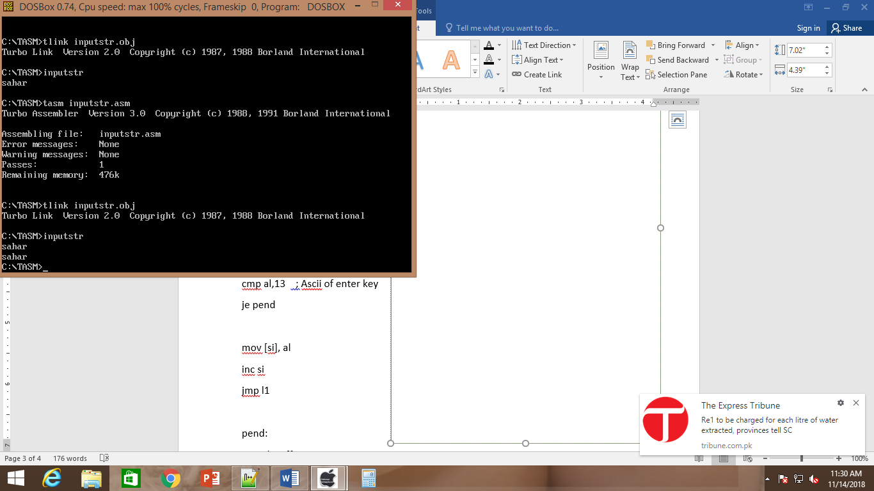

var1 db 100 dup('$')

.code

begin:

mov ax,@data

mov ds,ax

mov si,offset var1

l1:

mov ah,01

int 21h

cmp al,13 ; Ascii of enter key

je pend

mov [si],al

inc si

jmp l1

pend:

mov dx, offset var1

mov ah,09

int 21h

mov ah, 4ch

int 21h

end begin

**Program 3: Reverse the string.**

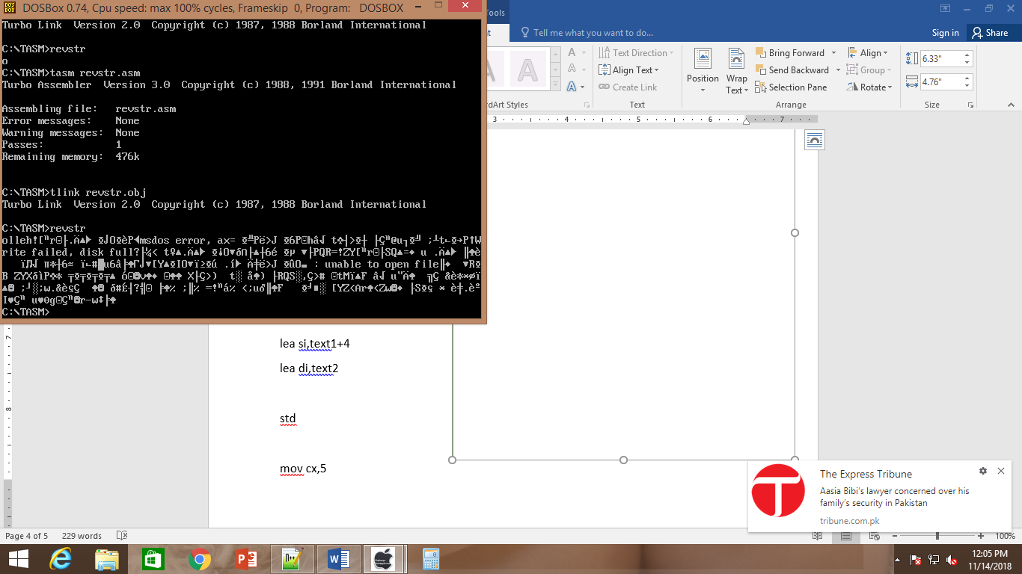

.model small

.stack 100h

.data

text1 db 'hello$'

text2 db 5 dup('0$')

.code

begin:

mov ax,@data

mov ds,ax

mov es,ax

lea si,text1+4

lea di,text2

std

mov cx,5

move:

movsb

add di,2

loop move

mov dx, offset text2

mov ah,09

int 21h

mov ah, 4ch

int 21h

end begin

**program 4: Copy String using Movesb.**

.model small

.stack 100h

.data

text1 db 'hello$'

text2 db 5 dup('0$')

.code

begin:

mov ax,@data

mov ds,ax

mov es,ax

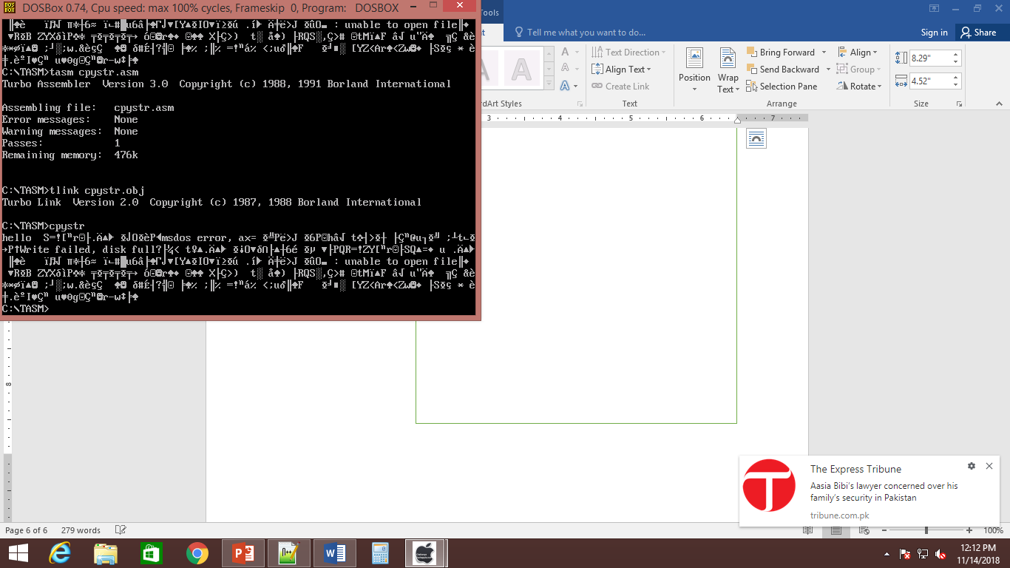

lea si,text1

lea di,text2

cld

mov cx,5

rep movsb

mov dx, offset text2

mov ah,09

int 21h

mov ah, 4ch

int 21h

end begin

**Program 5: Create a program using string instruction stosb to store content in variable from al register.**

.model small

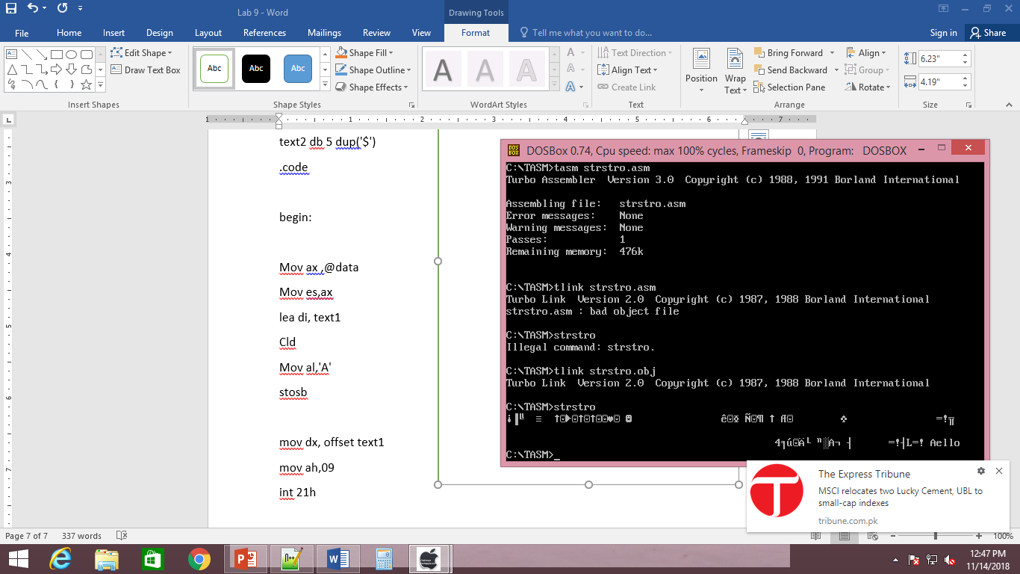

.stack 100h

.data

text1 db 'hello$'

text2 db 5 dup('$')

.code

begin:

Mov ax ,@data

Mov es,ax

lea di, text1

Cld

Mov al,'A'

stosb

mov dx, offset text1

mov ah,09

int 21h

mov ah, 4ch

int 21h

end begin

**Program 6: Create code which store A 5 times in variable which already contain any string using stosb string instruction.**

.model small

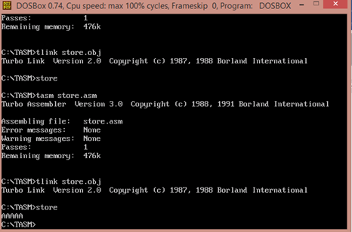.stack 100h

.data

str1 db "hello$"

str2 db 5 dup('0$')

.code

start:

mov ax,@data

mov es,ax

mov ds,ax

cld

mov cx,5

mov al,'A'

lea di, str1

repne stosb

mov ah,09

lea dx, str1

int 21h

mov ah,4ch

int 21h

end start

**Program 7 : Create program using load instruction.**

.model small

.stack 100h

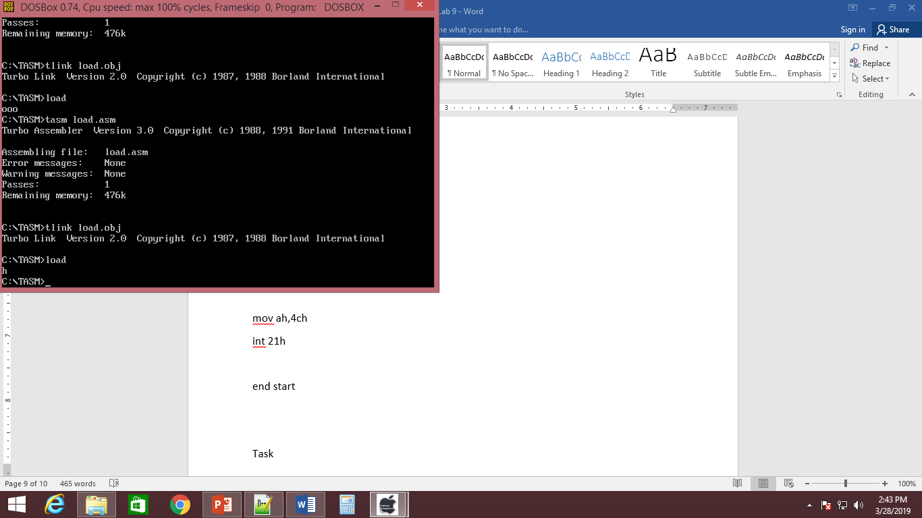.data

str1 db "hello$"

.code

start:

mov ax,@data

mov es,ax

mov ds,ax

lea si,str1

cld

lodsb

mov ah,02

mov dl, al

int 21h

mov ah,4ch

int 21h

end start

**Program 8 : Create program using Scan string operation**.

.model small

.stack 100h

.data

var db "A$"

.code

start:

mov ax,@data

mov ds, ax

mov es, ax

lea di, var

cld

mov al,'A'

scasb

jz equal

mov dl,49

mov ah,02

int 21h

jmp close

equal:

mov dl, 48

mov ah,02

int 21h

jmp close

close:

mov ah, 4ch

int 21h

end start

Task

Create a program which compare string and print message accordingly. Hint : use jg,jl

Create a program for Scan and compare string instruction.

Create program no 7 in lab manual using loop